What is Networking?
Networking refers to the practice of connecting computers, devices, and systems to share information, resources, and services. It enables communication between devices using wired or wireless technologies. Through networking, users can access shared files, printers, applications, and the internet. Networks help organizations improve efficiency, collaboration, and data management. They also support communication tools such as email, video calls, and messaging platforms. Networking forms the foundation of modern computing by allowing devices to exchange data smoothly and securely. Whether at home, in businesses, or across the world, networking plays a key role in connecting people and technology.
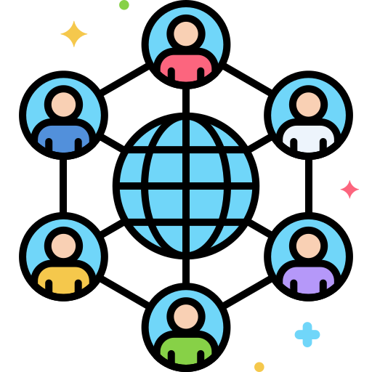
Examples: sharing files, using a shared printer, accessing the internet, etc.
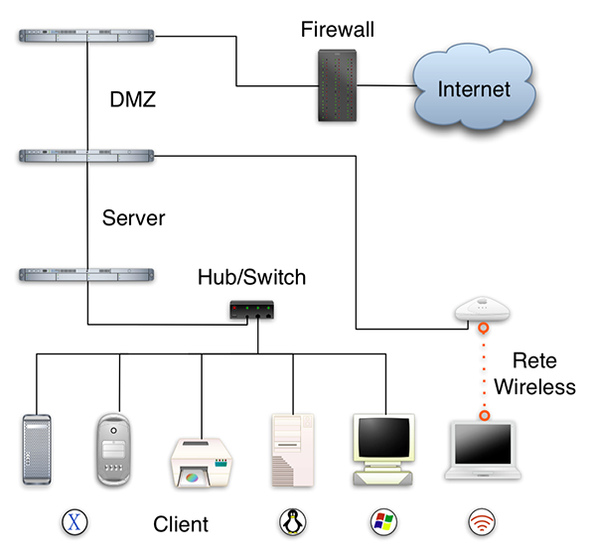
Types of Networks
1. LAN (Local Area Network)
A Local Area Network (LAN) connects devices like computers, printers, and phones within a small, specific area like a home, office, or campus, allowing them to communicate and share resources (files, internet) via Ethernet cables or Wi-Fi, creating a private network for fast, local data exchange.
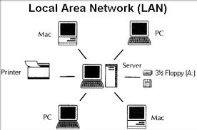

2. MAN (Metropolitan Area Network)
A Metropolitan Area Network (MAN) connects computers and networks across a city or large campus, bridging the gap between smaller Local Area Networks (LANs) and larger Wide Area Networks (WANs) by providing high-speed connectivity for data, voice, and video, often using fiber optics for efficient data sharing within an urban area, like cable TV networks or university campuses.
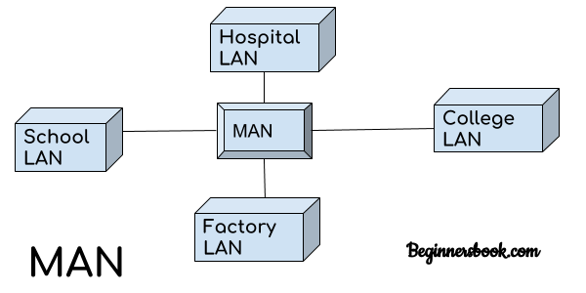

3. WAN (Wide Area Network)
A Wide Area Network (WAN) connects computers and smaller networks (like LANs) over large distances, such as cities, countries, or globally, enabling communication and resource sharing across different locations, with the Internet being the largest example; businesses use WANs to link offices, while technologies like leased lines, VPNs, MPLS, and SD-WAN facilitate these broad connections.
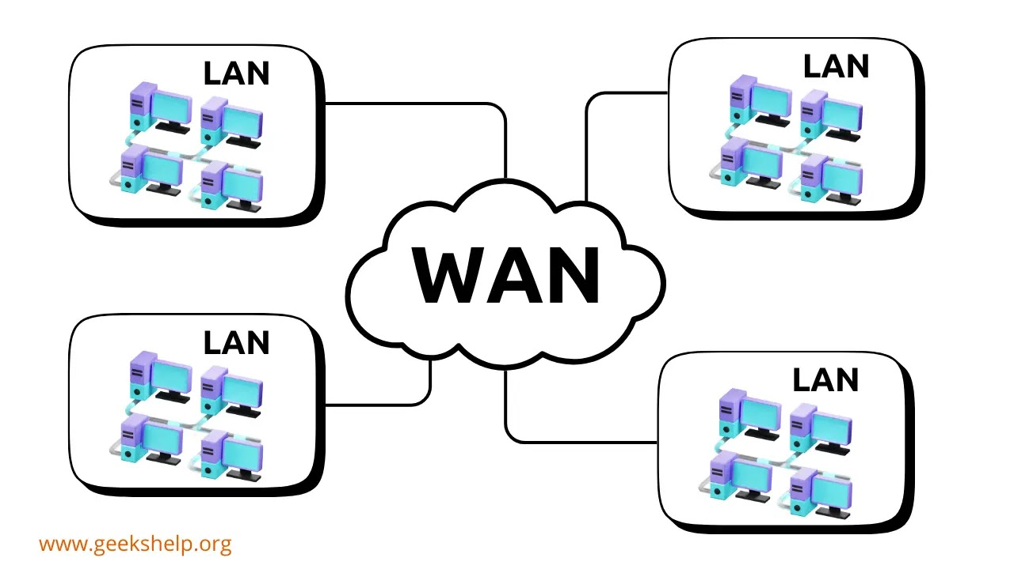

4. PAN (Personal Area Network)
A PAN (Personal Area Network) connects a few personal electronic devices (like phones, laptops, wearables) within a short range (around 10 meters) for data exchange, often wirelessly via Bluetooth or USB, focusing on an individual's immediate space for convenience, not broad internet access.
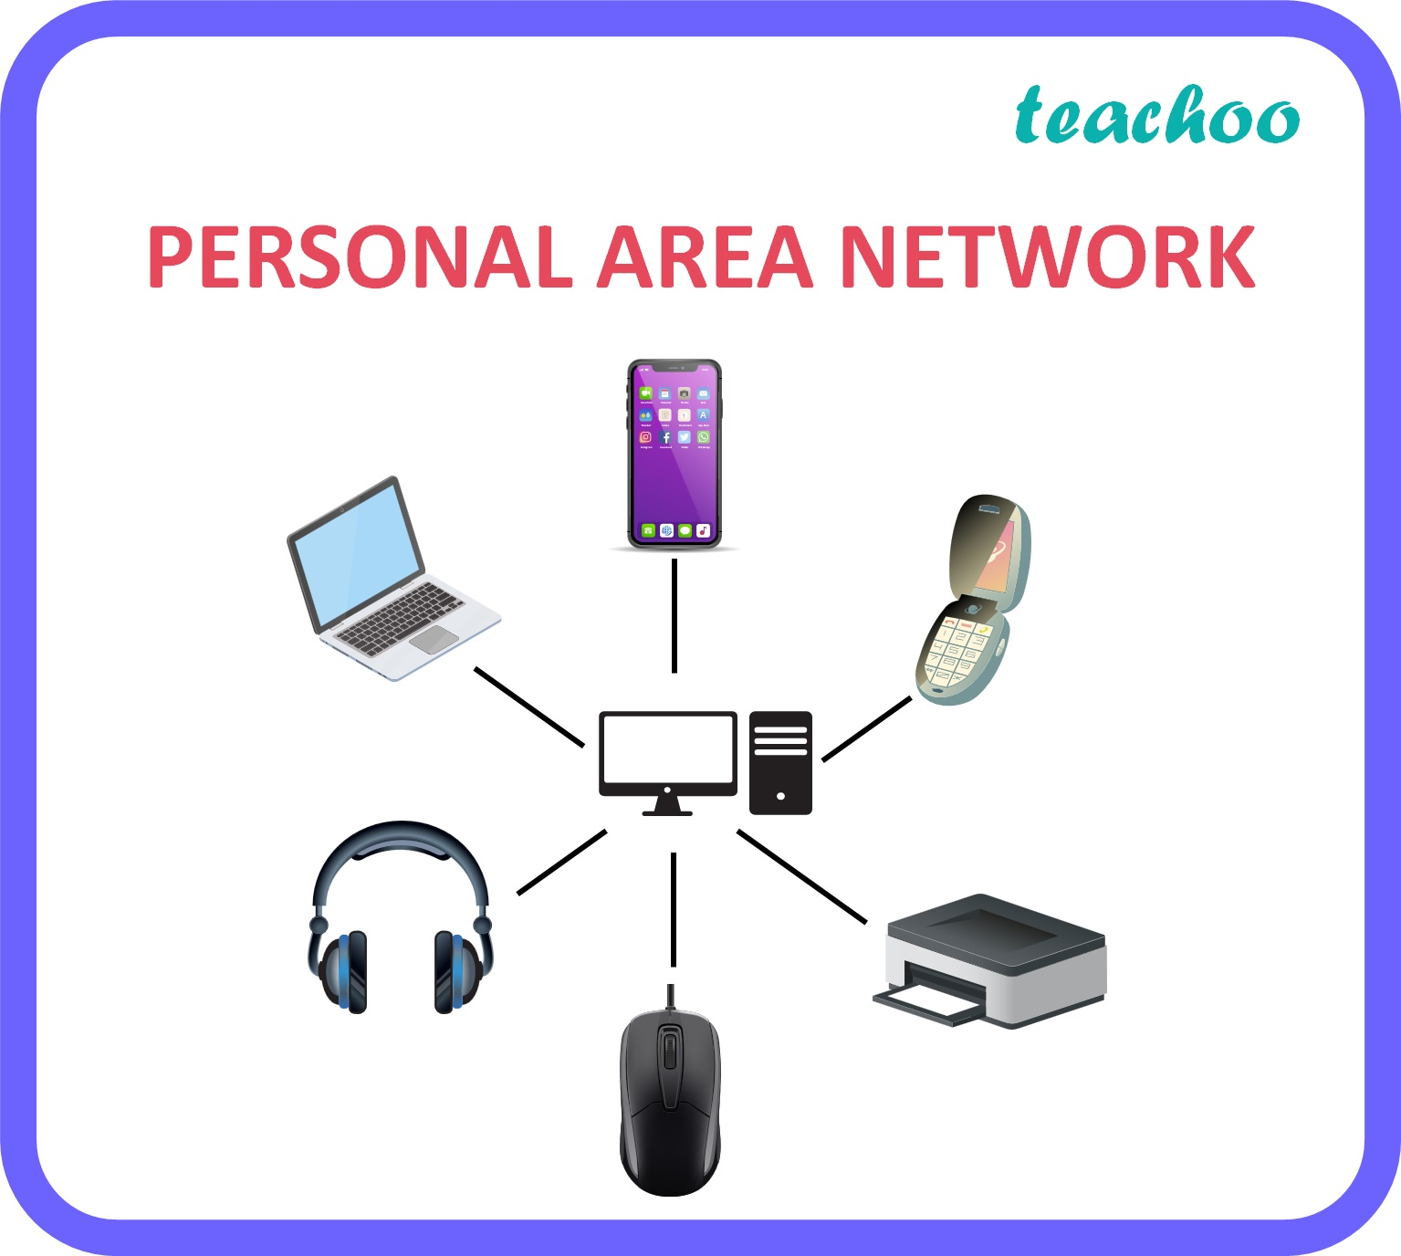

5. WLAN (Wireless LAN)
A WLAN (Wireless Local Area Network) is a network connecting devices in a limited area (home, office, campus) using radio waves instead of cables, with Wi-Fi being the most common technology (based on IEEE 802.11 standards) that uses access points to link computers, phones, and other devices to the internet or each other, offering flexibility but facing challenges like interference and security.
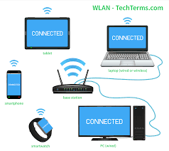

6. SAN (Storage Area Network)
A SAN network, or Storage Area Network, is a dedicated, high-speed network that provides multiple servers with access to consolidated block-level storage.
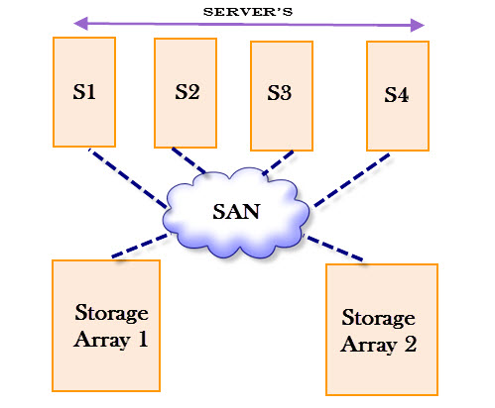

7. VPN (Virtual Private Network)
A VPN (Virtual Private Network) creates a secure, encrypted "tunnel" over the public internet, extending a private network to your device, masking your IP address, and protecting your data from snooping, allowing safe remote work, bypassing censorship, and ensuring online privacy by hiding your activity from your ISP and others. It works by routing your traffic through a remote server, encrypting everything, making your online presence private and secure.
